Microsoft Azure - Starter Kits for Partners

Hands on Lab

Cloud Hosted Apps

Dynamics AX with RDS

Last Update: March 2016





**MICROSOFT MAKES NO WARRANTIES, EXPRESS, IMPLIED OR STATUTORY, AS TO THE INFORMATION IN THIS DOCUMENT.**

The information contained in this document represents the current view of Microsoft Corporation on the issues discussed as of the date of publication. Because Microsoft must respond to changing market conditions, it should not be interpreted to be a commitment on the part of Microsoft, and Microsoft cannot guarantee the accuracy of any information presented after the date of publication.

Complying with all applicable copyright laws is the responsibility of the user. Without limiting the rights under copyright, no part of this document may be reproduced, stored in or introduced into a retrieval system, or transmitted in any form or by any means (electronic, mechanical, photocopying, recording, or otherwise), or for any purpose, without the express written permission of Microsoft Corporation.

Microsoft may have patents, patent applications, trademarks, copyrights, or other intellectual property rights covering subject matter in this document. Except as expressly provided in any written license agreement from Microsoft, the furnishing of this document does not give you any license to these patents, trademarks, copyrights, or other intellectual property.

The descriptions of other companies’ products in this document, if any, are provided only as a convenience to you. Any such references should not be considered an endorsement or support by Microsoft. Microsoft cannot guarantee their accuracy, and the products may change over time. Also, the descriptions are intended as brief highlights to aid understanding, rather than as thorough coverage. For authoritative descriptions of these products, please consult their respective manufacturers.

© 2015 Microsoft Corporation. All rights reserved. Any use or distribution of these materials without express authorization of Microsoft Corp. is strictly prohibited.

Microsoft and Windows are either registered trademarks of Microsoft Corporation in the United States and/or other countries.

The names of actual companies and products mentioned herein may be the trademarks of their respective owners.

Contents

Overview 4

Objectives 4

Prerequisites 4

Exercises 5

Infrastructure Provisioning 5

Exercise 1: Creating the Virtual Network 5

Exercise 2: Deploy a high availability environment on Azure (AX 2012) 6

Summary 7

## Overview

Using Microsoft Azure, as your Infrastructure as a Service (IaaS) platform, will enable you to create and manage your infrastructure quickly, provisioning and accessing any host ubiquitously. Grow your business through the cloud-based infrastructure, reducing the costs of licensing, provisioning and backup.

In this hands-on Lab, you will learn how to deploy a high availability environment on Microsoft Azure. To deploy the environment, you’ll use the Cloud-hosted environments tool in Microsoft Dynamics Lifecycle Services

**Estimated time** to complete this lab: **180 minutes**.

**Audience**: IT Pro, Architect, Application Owners

### Objectives

In this hands-on lab, you will learn how to:

* Create a Virtual Network with and Subnets
* Deploy a high availability environment on Microsoft Azure using Microsoft Dynamics Lifecycle Services.

The Hands On covers the following Architecture:

[**$Azure Starter Kits/Content/Starter Kit – AppServer/4 - Architecture – Visio.vsdx > Scenario**](https://github.com/AmericasPartnerServices/azure-starterkits/blob/master/Content/Starter%20Kit%20-%20AppServer/4%20-%20Architecture%20-%20Visio.vsdx) **3**

### Prerequisites

The following is required to complete this hands-on lab:

* A Microsoft Azure subscription - [sign up for a free trial](http://aka.ms/WATK-FreeTrial)
* [Azure PowerShell 0.7.4](http://go.microsoft.com/fwlink/p/?linkid=320376)  or higher
* [Windows PowerShell 3.0](http://go.microsoft.com/fwlink/p/?LinkId=393708) or higher

## Exercises

## Infrastructure Provisioning

### Exercise 1: Creating the Virtual Network

In this exercise, you will learn how to create a Virtual Network in Microsoft Azure.

#### Task 1 – Create Virtual Network

In this task, you will create a Cloud-Only Virtual Network in the Management Portal. When you create a virtual network, your services and VMs within the VNet can communicate securely with each other without having to go out through the Internet. Creating a dedicated cloud-only virtual network is a relatively fast and easy process. Because a cloud-only virtual network isn’t intended for cross-premises connectivity, you won’t need to acquire and configure a VPN device or authentication certificates.

1. Log in to the **Microsoft Azure Management Portal**.
2. In the lower left-hand corner of the screen, click **New**. In the navigation pane, click **Network Services**, and then click **Virtual Network**. Click **Custom Create** to begin the configuration wizard.
3. On the **Virtual Network Details** page, enter the information below:

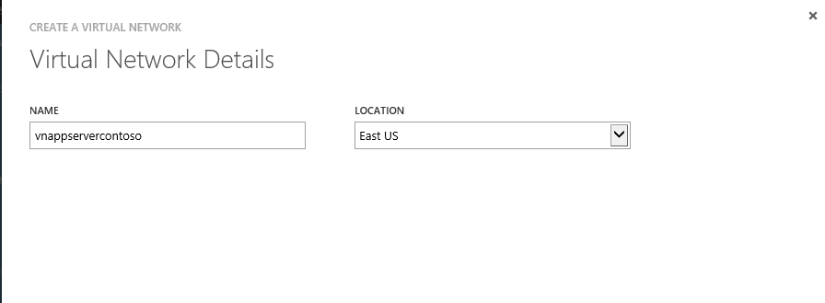

1. On the **DNS Servers and VPN Connectivity** page, don’t make any changes. Just move forward to the next page by clicking the arrow. By default, Azure provides basic name resolution for your virtual network. It’s possible that your name resolution requirements are more complex than can be handled by the basic Azure name resolution. In that case, you may later want to add a virtual machine running DNS to your virtual network.
2. The **Virtual Network Address Spaces** page is where you enter the address space that you want to use for this VNet.
3. Create the following subnets:

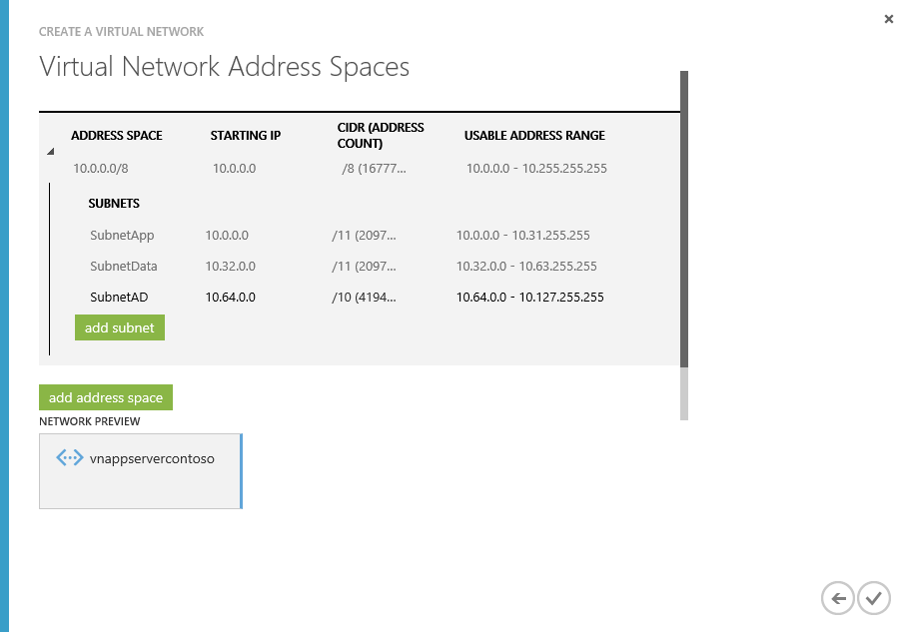

1. Click the checkmark on the lower right of the Virtual Network Address Spaces page and your virtual network will begin to create. When your virtual network has been created, you will see **Created** listed under **Status** on the **networks** page in the Management Portal.

### Exercise 2: Deploy a high availability environment on Azure (AX 2012)

1. This article explains how to deploy a high availability environment on Microsoft Azure. To deploy the environment, you’ll use the Cloud-hosted environments tool in Microsoft Dynamics Lifecycle Services.
2. Note: Make sure your use the VNET created in the previous steps.
3. **Scenario**: <https://ax.help.dynamics.com/en/wiki/deploy-a-high-availability-environment-on-azure/#1-use-azure-premium-storage>

## Summary

In this hands-on Lab, you have learnt how to deploy a high availability Dynamics AX environment on Microsoft Azure. To deploy the environment, you used the Cloud-hosted environments tool in Microsoft Dynamics Lifecycle Services